Image | 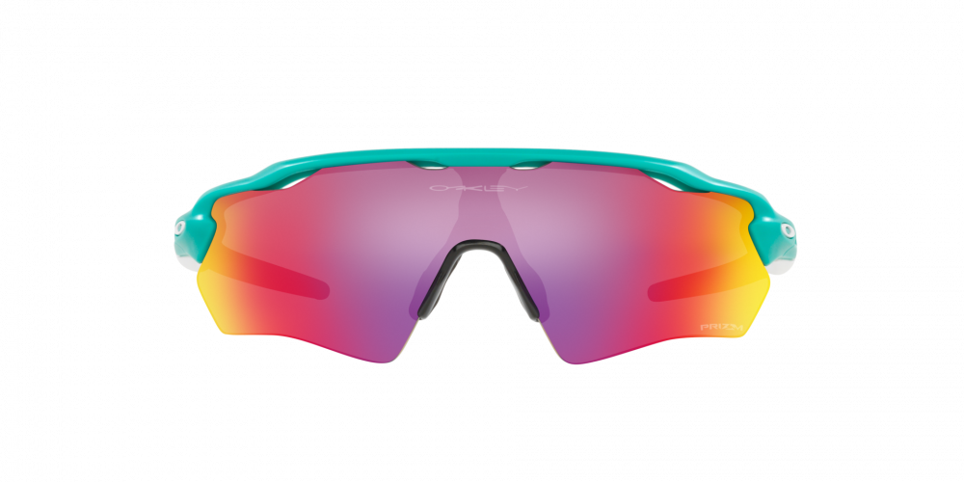
Brand | OAKLEY
Model Name | RADAR® EV XS HERITAGE COLORS
Price | RS 5199
PRODUCT DETAILS

